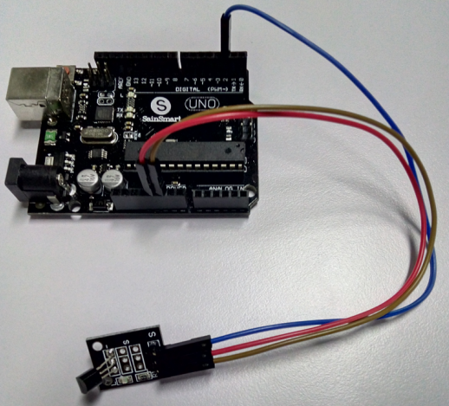

Code1:

#include <OneWire.h>

int DS18S20_Pin = 2; //DS18S20 Signal pin on digital 2

//Temperature chip i/o

OneWire ds(DS18S20_Pin); // on digital pin 2

void setup(void) {

Serial.begin(9600);

}

void loop(void) {

float temperature = getTemp();

Serial.println(temperature);

delay(100); //just here to slow down the output so it is easier to read

}

float getTemp(){

//returns the temperature from one DS18S20 in DEG Celsius

byte data[12];

byte addr[8];

if ( !ds.search(addr)) {

//no more sensors on chain, reset search

ds.reset_search();

return -1000;

}

if ( OneWire::crc8( addr, 7) != addr[7]) {

Serial.println("CRC is not valid!");

return -1000;

}

if ( addr[0] != 0x10 && addr[0] != 0x28) {

Serial.print("Device is not recognized");

return -1000;

}

ds.reset();

ds.select(addr);

ds.write(0x44,1); // start conversion, with parasite power on at the end

byte present = ds.reset();

ds.select(addr);

ds.write(0xBE); // Read Scratchpad

for (int i = 0; i < 9; i++) { // we need 9 bytes

data[i] = ds.read();

}

ds.reset_search();

byte MSB = data[1];

byte LSB = data[0];

float tempRead = ((MSB << 8) | LSB); //using two's compliment

float TemperatureSum = tempRead / 16;

return TemperatureSum;

}

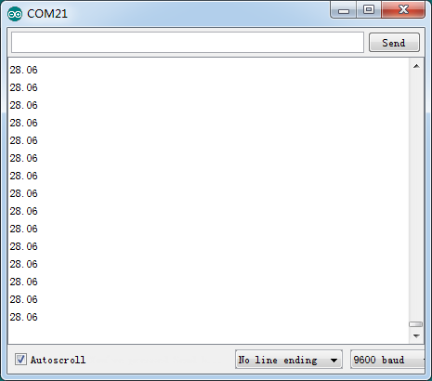

Code2:

#include <OneWire.h>

#include <DallasTemperature.h>

// Data wire is plugged into port 2 on the Arduino

#define ONE_WIRE_BUS 2

// Setup a oneWire instance to communicate with any OneWire devices (not just Maxim/Dallas temperature ICs)

OneWire oneWire(ONE_WIRE_BUS);

// Pass our oneWire reference to Dallas Temperature.

DallasTemperature sensors(&oneWire);

void setup(void)

{

// start serial port

Serial.begin(9600);

Serial.println("Dallas Temperature IC Control Library Demo");

// Start up the library

sensors.begin();

}

void loop(void)

{

// call sensors.requestTemperatures() to issue a global temperature

// request to all devices on the bus

Serial.print("Requesting temperatures...");

sensors.requestTemperatures(); // Send the command to get temperatures

Serial.println("DONE");

Serial.print("Temperature for the device 1 (index 0) is: ");

Serial.println(sensors.getTempCByIndex(0));

}

